+-+-+-+-+-+-+-+-+-+-+-+-+-+-+-+-+-+-+-+-+-+-+-+-+-+-+-+-+-+-+-+-+-+-+-+-+
Mansoor Zafar
100503226
mzafar15@myseneca.ca

+-+-+-+-+-+-+-+-+-+-+-+-+-+-+-+-+-+-+-+-+-+-+-+-+-+-+-+-+-+-+-+-+-+-+-+-+
Table of Contents:
- Control Panel Screen
  - Explanation of Screen UI + Functionality
  - Explanation of Design Principles
- Search Taxi Screen
  - Explanation of Screen UI + Functionality
  - Explanation of Design Principles
- Manage Taxi Screen
  - Explanation of Screen UI + Functionality
  - Explanation of Design Principles
- Add Taxi Screen
  - Explanation of Screen UI + Functionality
  - Explanation of Design Principles

+-+-+-+-+-+-+-+-+-+-+-+-+-+-+-+-+-+-+-+-+-+-+-+-+-+-+-+-+-+-+-+-+-+-+-+-+
Page: The control panel.
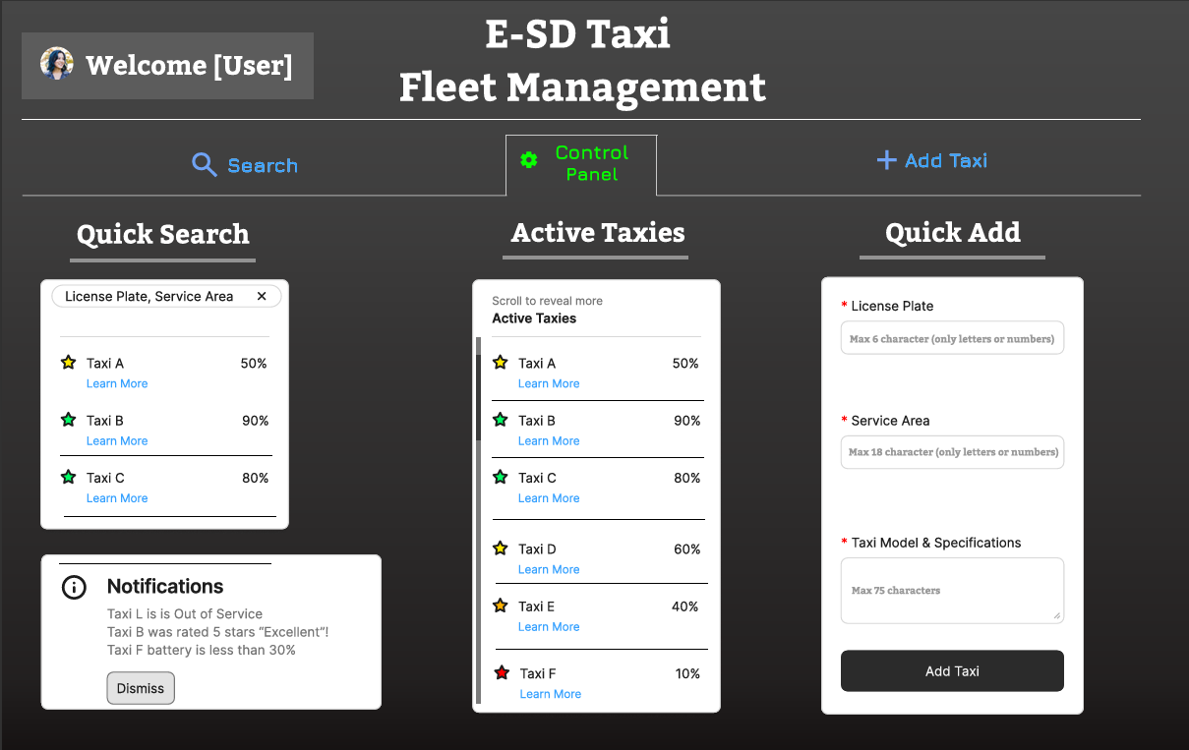
Table of Contents:
- Explanation of Screen:
- Explanation of Design Principles

- Explanation of Control Panel Screen:
This is the main home page that the user will start on. It shows the active taxis on the leftmost side, allows for a quick addition of a taxi (with validation), shows the notifications, allows for a quick search at the bottom right. It also has a nice welcome message to the user at the top right with their icon, the name of the app at the top and a navigation to the other screens/pages.

Firstly, for the “Active Taxis” list, it shows all active taxis in a list and allows for scrolling. It shows the Taxi name, a star with a color that indicates the battery percent, (green = good, yellow/orange = okay, red = bad), the actual battery percent and a learn more option.
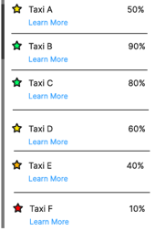
If the user selects the Learn more for a taxi listed here, it’ll redirect them to the Manage Taxi’s screen (more detail later, when I get to that screen) with the chosen Taxi.

This screen is normally hidden from the user as you’d need to select a specific Taxi to start managing one. They can either go from search to here or from the Quick Search / Active Taxis to reach this page.
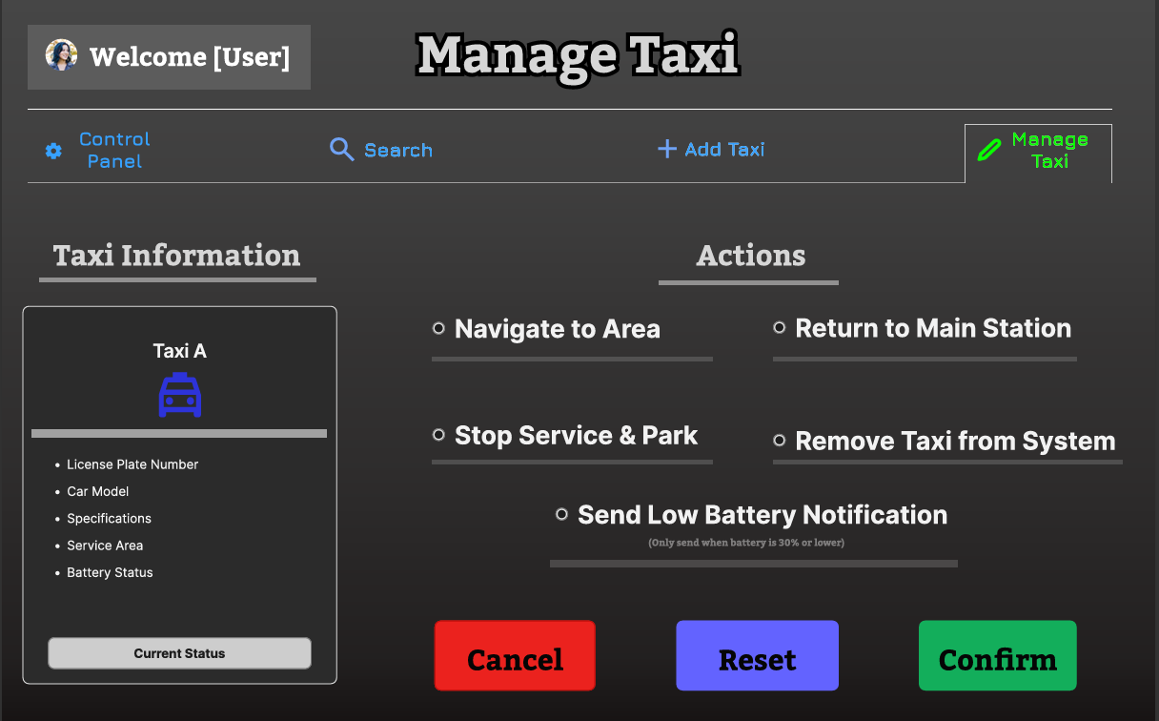 This is the Manage Taxi Screen.

Secondly, the Quick Add Taxi form. It has a red star next to all the required input fields and has a hint text that outlines the requirements. The License Plate input has the hint text “max 6 characters (only letters or numbers)” and will be made so that it can only take 6 letters or numbers, it cannot take any special characters. this is validated with a potential isLetterOrNumber function. The Service Area input has the hint text of “max 18 characters (only letters or numbers)” and will be made so it can only take 18 letters or numbers total. The Taxi Model & Specifications has the hint text of “Max 75 characters” and will only take up to 75 characters.
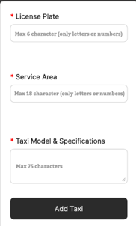
When the user tries to click the “Add Taxi” with an empty form or missing inputs, this will be a popup, and the input will not go through.
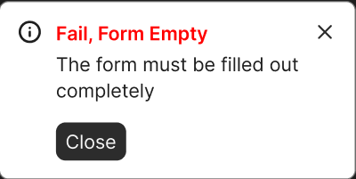
This popup has the title, “Fail, Form Empty” and has the description of “the form must be filled out completely” and a close button. It informs the User that the form must be fully filled out. While the user is inputting their data, if they input a special character and the potential isLetterOrNumber function doesn’t catch it, this popup will appear
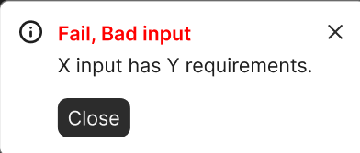
Where X is dynamically replaced with the input field’s title and Y dynamically replaced with the hint text of the respective input field (TLDR: X gets the bad input title and Y becomes the requirements). These popups will block submission until all requirements are met.

For the Quick Search
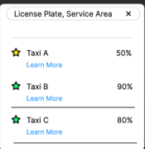
It takes in the License Plate and or the Service area separated by a comma as shown by “License plate, Service Area”. If no results exist, it’ll simply display that text in the result
“No results found”.

- Explanation of Design Principles

All the important information has labels above indicting what their functionalities are. For example, the Quick Search has a label above indicting, “Quick Search”.
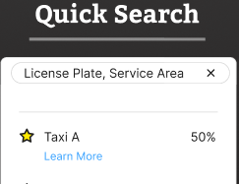
The interface has a very simple UI that is very self-explanatory that is easily remembered. There is error prevention for all areas of input and for when I cannot prevent the error, there are detailed popups that notify the user of the exact issue. For instance, the input for License Plate should only take in letters and characters but if somehow a user finds a bypass, then there is a pop-up that informs the user of the issue. Furthermore, there are hint texts for all those inputs that tell the user the direct requirements.
This UI also is very consistent with both its colour schemes, fonts and wording. All wording is simple, easy to understand and clear. The user doesn’t have to guess what “Quick add” means or even “Learn More”. They have clear meaning with no hidden agendas. Furthermore, I highlighted the active page in green and had the other pages be coloured blue. It helps the user easily understand the current page they are on. Finally, I matched between systems and the real world with the battery showcase. I used stars that contained specific colours which correlated with the battery percents. I chose a common battery theme, red = low/bad, orange/yellow = okay and green = good.
One other design principal I followed was the minimalism. All the information shown is relevant and it’s not too clustered or full.

+-+-+-+-+-+-+-+-+-+-+-+-+-+-+-+-+-+-+-+-+-+-+-+-+-+-+-+-+-+-+-+-+-+-+-+-+
Page: Search Taxi Screen.
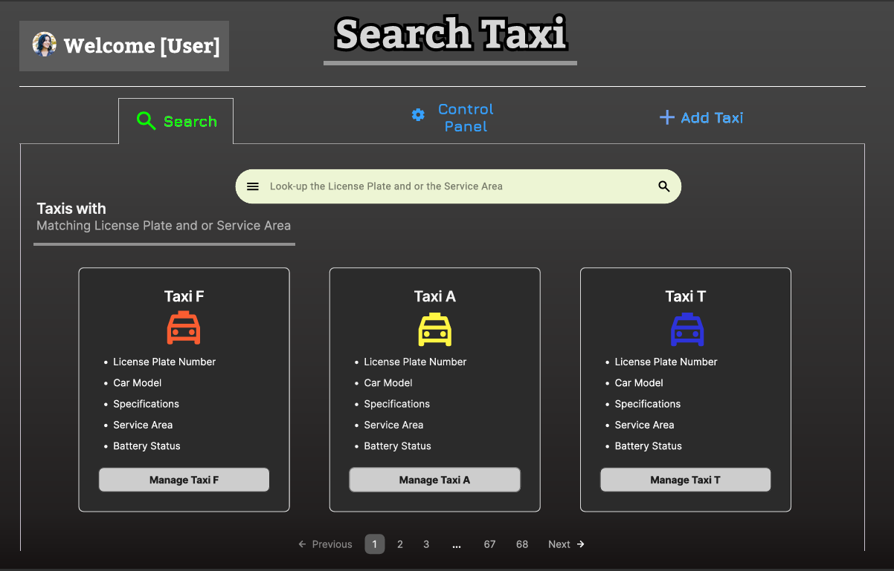
Table of Contents:
- Explanation of Screen:
- Explanation of Design Principles

- Explanation of Search Taxi Screen:

This is the page for searching for taxis. It shows the screen name at the top, the user profile at the top right, a navigation to the different pages/screens, a search input, a search hint, results and a pagination.

By default, it’ll show all the taxis that exist. Each taxi is shown in a card format, where the card has the Taxi name, the taxi image, the license plate number, car model, specifications, service area and the battery status on the card alongside a Manage Taxi [name] button.

The search has a hint of “Look up the License plate and or the Service Area” and to the left of the search, there is the text, “Taxis with Matching License Plates and or Service Area”. So, the user will always be aware of what to search with. If the user inputs an invalid search, the result will just have the text
“No resulting matching, [X License Plate], [Y Service Area]. Please Input in this format: License Plate (Optional), Service Area (Optional). Or leave it blank to get all results.”
The System will show results that contain the letters from the search bar. So, if they user typed ‘L’, ‘M’, it would show taxis that have their License Plate contain the letter ‘L’ and service areas that contain the letter ‘M’.

If the user selects the “Manage Taxi [name]” button, then they will be led to the Manage Taxi screen.
 Manage Taxi [name] Button
That button leads to this page with the specific taxi presented in Taxi Information. (More details later)
 Manage Taxi Screen
The Pagination at the bottom will display more results, as each page displays up to 3 taxi’s, you can navigate to previous or next pages or just press the 3 .’s … to access a specific page.

The current page you are on, will be highlighted in gray.

- Explanation of Design Principles

This has a very minimalist design, it’s simple, easy to understand, memorable and doesn’t need much thought. Any users using would have a clear understanding of the order of the page, how to search and how to use it. Then, there comes to errors, the error message that appears is informative, as it tells the user directly that there are no taxis with such information. It also reiterates the optional fields and how to format their lookup. Furthermore, all search results stand out as they stand out the most on the page as they take up the most space and are most noticeable. None of the designs are forced in an area, there’s a lot of free space and it’s not too clustered.
The User is always able to simply set the search bar to empty, to show all results, and this also helps follow the Systems Visibility principal. The system shows results in real-time, changing results as you type more letters. So, if I added ‘l’,’l’ it would start immediately showing taxis that have a license plate containing ‘l’ and their service area containing with ‘l’. I chose to have to so the system shows the results containing the letters as it helps users more easily type keywords that are contained within the results, rather than memorizing the entire words.
All the words and phrases, mean exactly what they say. They’re all simple common words, so the user can easily recognize and understand each word and their meaning.

+-+-+-+-+-+-+-+-+-+-+-+-+-+-+-+-+-+-+-+-+-+-+-+-+-+-+-+-+-+-+-+-+-+-+-+-+
Page: Manage Taxi Screen.
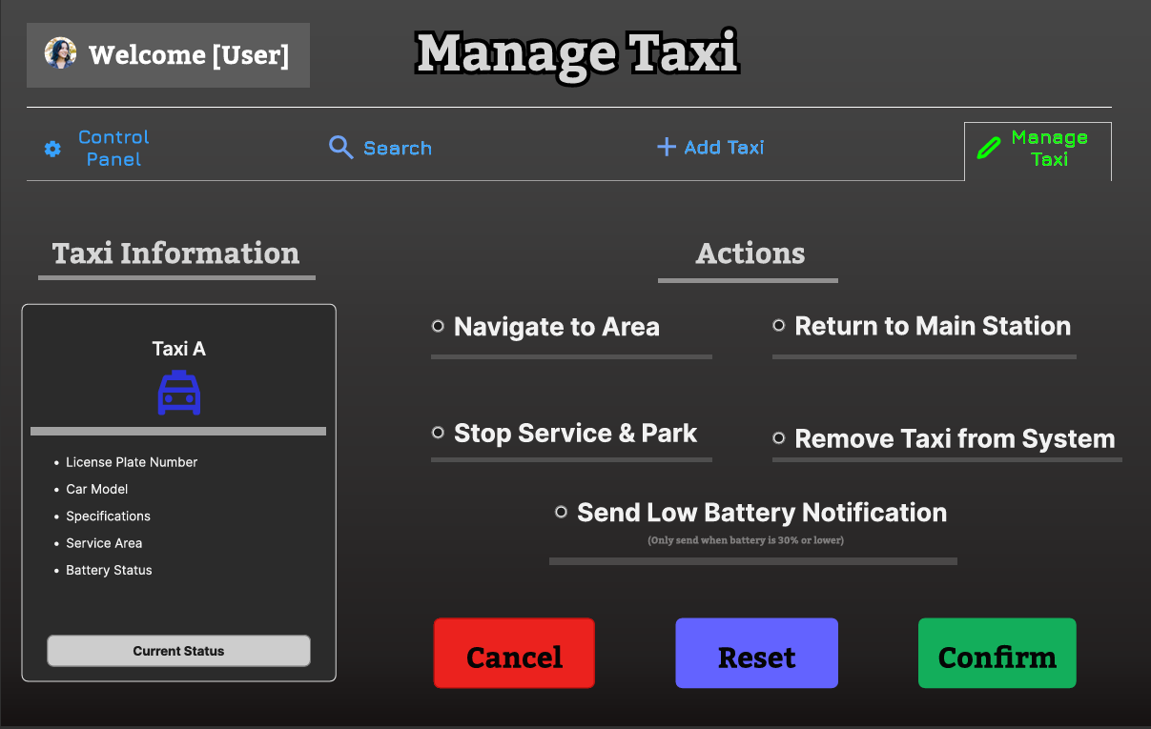
Table of Contents:
- Explanation of Screen:
- Explanation of Design Principles

- Explanation of Manage Taxi Screen:
This is the page for managing a specific Taxi. You can only access this screen after selecting either “Learn More” from the Control Page or selecting the “Manage Taxi [name]” from the Search Page. It shows the screen name at the top, the user profile at the top right, a navigation to the different pages/screens and at the leftmost side, you are shown an overview of the selected Taxi and its information.

The overview includes, name of the Taxi, License Plate number, specifications, Service Area, Battery Status and a button for the “current status”.

The button “Current Status” will show a popup with its progress towards completion if applicable.
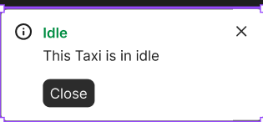
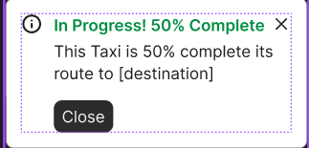
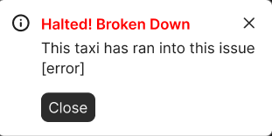
Depending on the Taxi’s status, it’ll display one of the above. The number for completion will be the % it’s at and not just 50%. Each exist for a respective purpose, idle popup if the taxi is idle, in progress popup if the taxi is ongoing and the halted popup if the taxi has an issue.

Then you have the actions. These are the actions you can perform, they are a group of radio buttons, meaning you can only choose one option. These actions are, Navigate to Area, Return to Main Station, Stop Service & Park, Remove Taxi from System and Send Low Battery Notification.

The last action, Send Low Battery Notification, has a miniature label underneath saying, “only send when battery is 30% or lower”
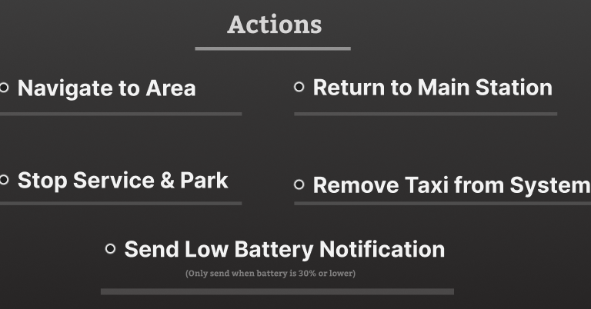
You also have 3 buttons, “Cancel”, “Reset” and “Confirm”. Cancel will cancel the management and send you back to the previous screen (The one you came from). Reset will reset the radio buttons to be set to empty and confirm will bring up a confirmation.

If nothing is selected then the Confirm button will appear more shaded out and become smaller as to indicate its disabled,

And when the user hovers over it, trying to select it despite this, this message will be shown
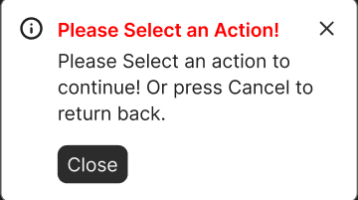

After an action is selected, the button will go back to being regular green and bigger in size.

If the user selects Navigate to Area action and presses continue, this will appear for them.
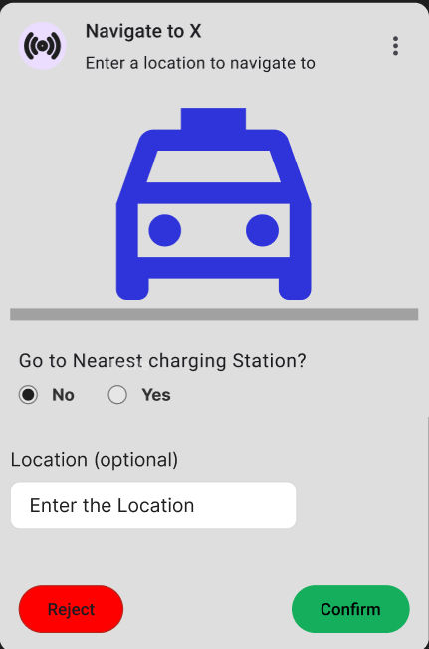
They are given an input box for the location if they so choose a radio button for yes and no to choose if they want to go to the nearest charging station and a reject or confirm button.

If the user rejects, they will be sent back to the Manage Taxi Screen


If the user confirms and it’s a valid area, they will get this popup,
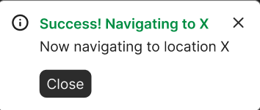
This popup says success, navigating to X with a ‘close’ button. Where X is either the nearest changing station or the location. Then when they press the close button, they are returned to the Manage Taxi Screen.

If the user enters an invalid location, this popup will be shown
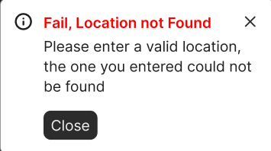
Then they will be brought back to the confirmation
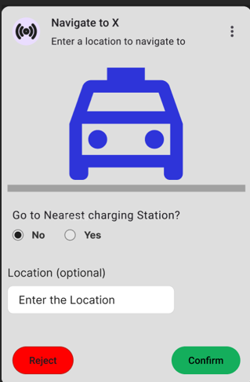

If the user chooses the Return to Main Station action they are given this popup.
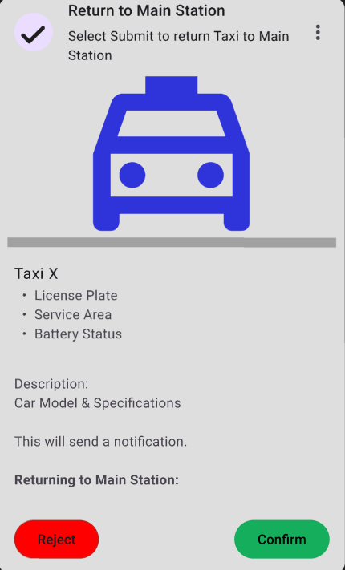
Here the user is given an overview of the Taxi and 2 buttons that can either reject or confirm. The overview includes, name of the Taxi, License Plate number, specifications, Service Area and Battery Status.

The reject will just redirect them back to the Manage Taxi screen. The confirm will give this popup
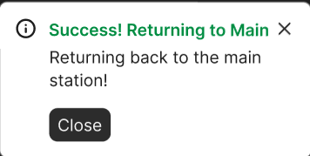
The popup says success, returning to Main Station with a ‘close’ button. Which if pressed then they will be returned to the Manage Taxi Screen.

If the user selects the Stop Service & Park action, they are presented with this popup:
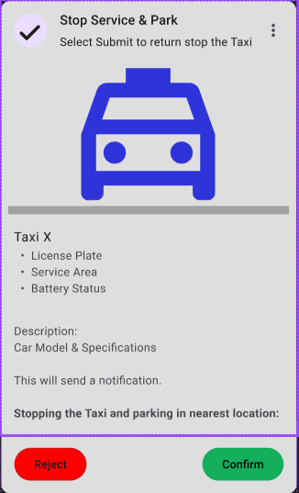
This comes with an overview of the taxi and 2 buttons, a reject and confirm.
The overview includes, name of the Taxi, License Plate number, specifications, Service Area and Battery Status.

The reject will return them back to the Manage Taxi, and the Confirm will give a popup that looks like
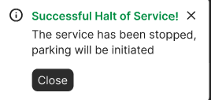
It’s a success popup that says the service has been halted with a ‘close’ button. After clicking the ‘Close’ button, it will redirect them back to the Manage Taxi screen.

If the user selects the Remove Taxi action, this popup will be shown
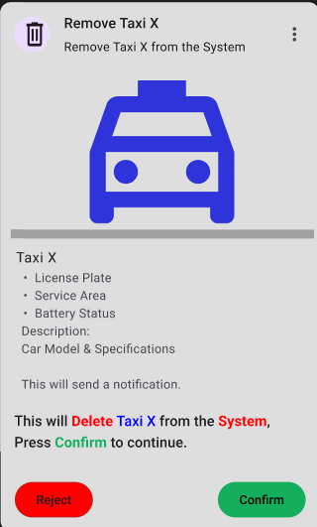
The user is shown an overview of the Taxi, a reminder message saying, that

This action will delete the Taxi from the System entirely and if they want to continue, they should press confirm.

If the user presses the Reject button, they will be sent back to the Manage Taxis Screen. If the user presses the Confirm button, they will be shown this popup and sent back to the Manage Taxis screen
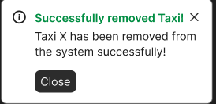
This popup says the taxi was removed successfully and has a close button, when pressed, will return the user to the Manage Taxi screen

If the battery status is more than 30% then the Send Low Battery Notification Action will be more shaded out to indicate its disabled

If the user hovers over it still trying to select it, this message will popup
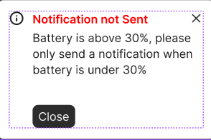
This is an error message that tells the user the battery is above 30% and to only send a message when the battery is 30% or lower.

If the battery is 30% or lower and the user sends a low battery notification, you will get this popup
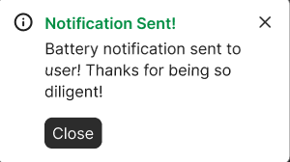
This popup says it was a success and sends you back to the Manage Taxi Screen after clicking the ‘close’ button.

- Explanation of Design Principles

My design is very much error proof, easy to understand and follow and has a minimalist aspect. The design matches between the system and the real world by having all the colours match with common interpretations. Red meaning cancels or error, blue meaning reset and green meaning success or confirm. Same with the shaded-out parts, for instance, the confirm button being shaded out if no action is selected, this is commonly associated with disabled buttons. Furthermore, the user has a clear exit and at any reasonable point back out from their decisions. After choosing any action, they are given a confirmation where they are re-told their choice and still given a choice to back out. Similarly, all the word choices are consistent. I chose “confirm” as the term to keep moving forward throughout the entire area, there isn’t a point where it changes and confirm is commonly used as a continue option.

Then, I also ensured that the user always knew what they were doing by having the confirmation popups reiterate all the current information and what the result will be. For instance, for deleting a taxi, the popup reiterates that if the user clicks confirm again, the selected taxi (which is shown here) will be deleted from the system.

All the objects are very self-explanatory and clear, the order in which everything comes is very understandable and easy to follow. There aren’t too many objects, so its not clustered and doesn’t have too many steps.

+-+-+-+-+-+-+-+-+-+-+-+-+-+-+-+-+-+-+-+-+-+-+-+-+-+-+-+-+-+-+-+-+-+-+-+-+
Page: Add Taxi Screen.
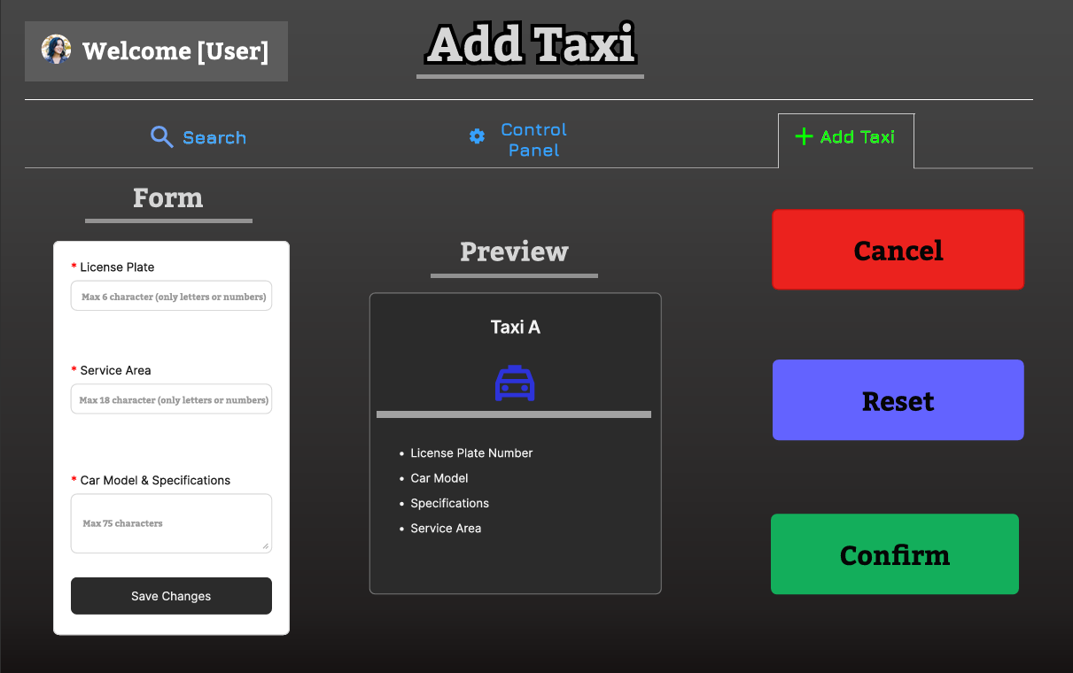
Table of Contents:
- Explanation of Screen:
- Explanation of Design Principles

- Explanation of Add Taxi Screen:

This is the page for creating/adding a Taxi into the system. On this page there the page name at the top, the navigation buttons, a form to input the details, a preview and 3 buttons, cancel, reset and confirm.

The form has a red star next to all the required input fields and has a hint text that outlines the requirements. The License Plate input has the hint text “max 6 characters (only letters or numbers)” and will be made so that it can only take 6 letters or numbers, it cannot take any special characters. this is validated with a potential isLetterOrNumber function. The Service Area input has the hint text of “max 18 characters (only letters or numbers)” and will be made so it can only take 18 letters or numbers total. The Taxi Model & Specifications has the hint text of “Max 75 characters” and will only take up to 75 characters.
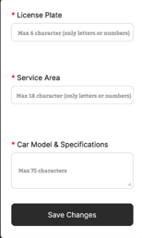
When the user tries to click the “Save Changes” with an empty form or missing inputs, this will be a popup, and the input will not go through.

This popup has the title, “Fail, Form Empty” and has the description of “the form must be filled out completely” and a close button. It informs the User that the form must be fully filled out. While the user is inputting their data, if they input a special character and the potential isLetterOrNumber function doesn’t catch it, this popup will appear

Where X is dynamically replaced with the input field’s title and Y dynamically replaced with the hint text of the respective input field (TLDR: X gets the bad input title and Y becomes the requirements). These popups will block submission until all requirements are met.

After the “Save Changes” button is pressed and valid, dynamically the Preview will be updated with the updated information.
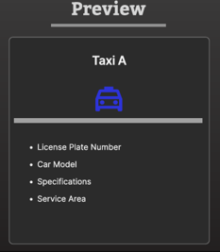

The preview will contain the License plate number, car model, specifications and the Service Area.

Then you have the 3 buttons, Cancel, Reset and Confirm. Cancel will send the user back to the previous page. Reset will just empty the form.

If the form is invalid then the Confirm button will appear more shaded out and become smaller as to indicate its disabled,

And when the user hovers over it, trying to select it despite this, this message will be shown
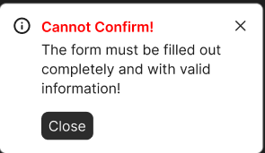
After the form is filled out with valid changes, and “Save changes” was pressed, the button will go back to normal size and brighter.

When the form is all valid and the user selects Confirm, this popup will be shown
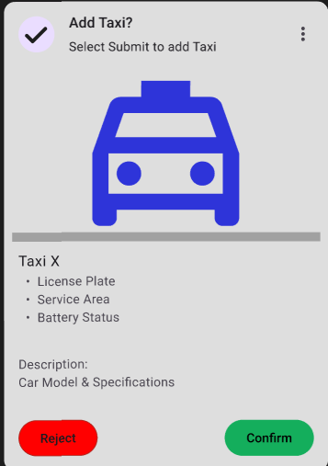

This popup shows a confirmation with the Taxi information from the form and a Reject and Confirm button.

If the Reject button is pressed, it will close the popup and bring the user back to the Add Taxi Screen will all the information still there.

If the Confirm button is pressed, the user will receive this notification and popup
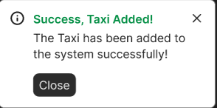
This notification says it was a success and has a close button. After the user presses the close button, it will return them back to the Add Taxi screen with the information all cleared.

- Explanation of Design Principles

It has a very minimalist design with a very simple and easy to follow UI. Firstly, error prevention, while the form Is not valid, the confirm button will be shaded-out and unelectable and when the user hovers over it, it’ll give the reasoning as a little bubble saying why you can’t click it yet. Furthermore, when you first confirm, you are then brought onto a confirmation popup, this gives you another chance to back-out if you so desire.

The order of the layout is clear and easy to follow. The user can understand immediately the order of the layout and how to follow it. Furthermore, the most important part of this UI, the form is also the one that stands out the most among the other elements.

